问题-三维本征频率问题
$$∇×μ_{r}^{-1}∇×E-k_{0}^{2}ϵ_{r}E=0$$
其中$k_{0}=ω\sqrt{μ_{0}ϵ_{0}}=\frac{ω}{c}=\frac{2πf}{c}$自由空间波数，$μ_{r}取1$
$$\iiint{\left(∇×E\right)\left(∇×W\right) dV}=k_{0}^{2}\iiint{ϵ_{r}E⋅W dV}$$
$E=\sum_{j}{e_{j}N_{j}^{e}}$，$W$遍历$N_{i}^{e}$
$$Ax=k_{0}^{2}Bx$$
$$x=\left[\begin{matrix}e_{1} \\ ⋮ \\ e_{n}\end{matrix}\right]$$
$$A_{ij}=\iiint{\left(∇×N_{i}^{e}\right)\left(∇×N_{j}^{e}\right) dV}$$
$$=\iiint{\left(\frac{J^{T}}{\det\left(J\right)}∇×N_{i}\right)\left(\frac{J^{T}}{\det\left(J\right)}∇×N_{j}\right)|\det\left(J\right)|dV}$$
$$=\sum_{k=1}^{n}{w_{k}\left(\frac{J^{T}}{\det\left(J\right)}∇×N_{i}\left(r_{k}\right)\right)\left(\frac{J^{T}}{\det\left(J\right)}∇×N_{j}\left(r_{k}\right)\right)|det\left(J\right)|}$$
$$B_{ij}=\iiint{ϵ_{r}N_{i}^{e}⋅N_{j}^{e} dV}=\iiint{ϵ_{r}{J^{-1}N}_{i}⋅{J^{-1}N}_{j}|det⁡(J)|dV}=\sum_{k=1}^{n}{w_{k}ϵ_{r}{J^{-1}N}_{i}\left(r_{k}\right)⋅{J^{-1}N}_{j}\left(r_{k}\right)|det⁡(J)|}$$

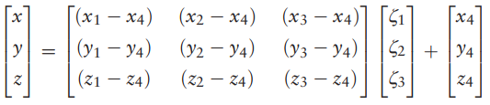
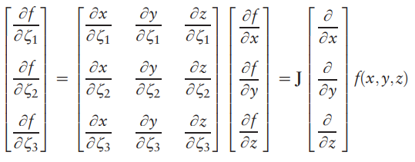
$J=\left[\begin{matrix}x_{1}-x_{4} & y_{1}-y_{4} & z_{1}-z_{4} \\ x_{2}-x_{4} & y_{2}-y_{4} & z_{2}-z_{4} \\ x_{3}-x_{4} & y_{3}-y_{4} & z_{3}-z_{4}\end{matrix}\right]$

$P_{0}/P_{4}顶点 \left(x_{4},y_{4},z_{4}\right)→(0,0,0)$
$P_{1}顶点 \left(x_{1},y_{1},z_{1}\right)→(1,0,0)$
$P_{2}顶点 \left(x_{2},y_{2},z_{2}\right)→(0,1,0)$
$P_{3}顶点 \left(x_{3},y_{3},z_{3}\right)→(0,0,1)$
6个矢量基函数
$N_{i}={|l}_{i}|α_{i}$
$l_{1}=\overset{⃑}{P_{4}P_{1}} α_{1}=\left(1-ξ_{2}-ξ_{3},ξ_{1},ξ_{1}\right)$ $\{0,-2,2\}$
$l_{2}=\overset{⃑}{P_{4}P_{2}} α_{2}=\left(ξ_{2},1-ξ_{1}-ξ_{3},ξ_{2}\right)$ $\{2,0,-2\}$
$l_{3}=\overset{⃑}{P_{4}P_{3}} α_{3}=\left(ξ_{3},ξ_{3},1-ξ_{1}-ξ_{2}\right)$ $\{-2,2,0\}$
$l_{4}=\overset{⃑}{P_{1}P_{2}} α_{4}=\left(-ξ_{2},ξ_{1},0\right)$ $\{0,0,2\}$
$l_{5}=\overset{⃑}{P_{1}P_{3}} α_{5}=\left(-ξ_{3},0,ξ_{1}\right)$ $\{0,-2,0\}$
$l_{6}=\overset{⃑}{P_{2}P_{3}} α_{6}=\left(0,{-ξ}_{3},ξ_{2}\right)$ $\{2,0,0\}$

$\left(0,0,0\right) 1-ξ_{1}-ξ_{2}-ξ_{3}$
$\left(1,0,0\right) ξ_{1}$
$\left(0,1,0\right) ξ_{2}$
$\left(0,0,1\right) ξ_{3}$

