计算电磁学第六次讲义
修正的Maxwell’ equation：
$$∇×E=-jωμ\left(1+\frac{σ_{m}}{jωμ}\right)H \tilde{μ}=μ(1+\frac{σ_{m}}{jωμ})$$
$$∇×H=-jωϵ\left(1+\frac{σ}{jωϵ}\right)E \tilde{ϵ}=ϵ(1+\frac{σ}{jωϵ})$$
反射率：
$$R\left(θ\right)=e^{-2η\cos{θ}\int_{0}^{d}{σ_{x}(x)dx}}$$
$$\left|R(θ)\right|=e^{-2κ_{2}s^{''}L\cos{θ}} κ^{2}=ω^{2}μϵ s_{z}=s^{'}-js^{''} (jian-ming jin 电磁有限元)$$
PML Grading（Polynomial）多项式形式
$$η^{2}=\frac{μ}{ϵ}={\left(\frac{k}{ωϵ}\right)}^{2} \frac{σ_{m}}{μ}=\frac{σ}{ϵ} σ_{m}=ση^{2} σ、σ_{m}带方向的,xyz三分量可能不同$$
$$σ_{x}\left(x\right)={\left(\frac{x}{d}\right)}^{m}σ_{x,max} κ_{x}\left(x\right)=1+\left(κ_{x,max}-1\right)⋅{\left(\frac{x}{d}\right)}^{m}$$
$$R\left(θ\right)=e^{-2ησ_{x,max}d\cos{θ}/(m+1) } σ_{x,max}=-\frac{\left(m+1\right)\ln\left[R(0)\right]}{2ηd}$$
PML Grading（Geometric）
$$σ_{x}\left(x\right)={\left(g^{1/Δ}\right)}^{x}σ_{x,0} κ_{x}\left(x\right)={\left[{\left(κ_{x,max}\right)}^{1/d}g^{1/Δ}\right]}^{x}$$
$$R\left(θ\right)=e^{-2ησ_{x,0}Δ\left(g^{\frac{d}{Δ}}-\right)\cos{θ}/\ln{g}} σ_{x,0}=-\frac{\ln{[R(0)]}\ln{g}}{2ηΔ(g^{\frac{d}{Δ}}-1)}$$
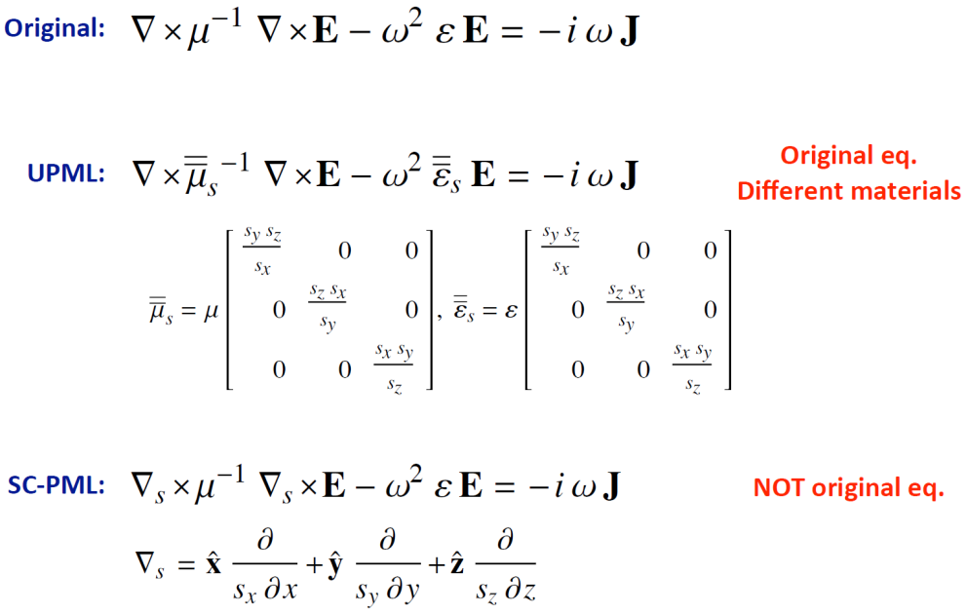
修正的Maxwell’ equation：
$$∇×E=-jωμ\left(1+\frac{σ_{m}}{jωμ}\right)H \tilde{μ}=μ(1+\frac{σ_{m}}{jωμ})$$
$$∇×H=-jωϵ\left(1+\frac{σ}{jωϵ}\right)E \tilde{ϵ}=ϵ(1+\frac{σ}{jωϵ})$$
相位匹配条件要求
$$\frac{σ_{m}}{μ}=\frac{σ}{ϵ}$$
因此有
$$1+\frac{σ_{m}}{jωμ}=1+\frac{σ}{jωϵ}$$
所以后续中有$\overline{ϵ}=ϵ\overline{Λ}$ $\overline{μ}=μ\overline{Λ}$

坐标拉伸 和 各向异性介质 关系
坐标拉伸分别对x，y，z进行复拉伸，x、y、z的拉伸因子分别为$s_{x},s_{y},s_{z}$
各向异性介质中，$\overline{ϵ}=ϵ\overline{Λ}$ $\overline{μ}=μ\overline{Λ}$
$$\overline{Λ}=\left[\begin{matrix}\frac{s_{y}s_{z}}{s_{x}} & 0 & 0 \\ 0 & \frac{s_{x}s_{z}}{s_{y}} & 0 \\ 0 & 0 & \frac{s_{x}s_{y}}{s_{z}}\end{matrix}\right]$$
复拉伸可以写成各向异性介质形式

complex-frequency shifted PML (CFS-PML)有：
$$s_{j}=κ_{j}+\frac{σ_{j}}{α_{j}+jωϵ}$$
通常取$κ_{j}=1,α_{j}=0$
$$s_{j}=1+\frac{σ_{j}}{jωϵ}=1-j\frac{σ_{j}}{ωϵ}$$
$$R_{1}\left(θ\right)=e^{-2η\cos{θ}\int_{0}^{d}{σ_{j}\left(x\right)dx}}(计算电磁学课) R_{2}\left(θ\right)=e^{-2\cos{θ}ω\sqrt{μϵ}\int_{0}^{d}{\frac{σ_{j}\left(x\right)}{ωϵ}dx}}(电磁有限元)$$
$$-2\cos{θ}ω\sqrt{μϵ}\int_{0}^{d}{\frac{σ_{j}\left(x\right)}{ωϵ}dx}=-2\cos{θ}\sqrt{\frac{μ}{ϵ}}\int_{0}^{d}{σ_{j}\left(x\right)dx}=-2η\cos{θ}\int_{0}^{d}{σ_{j}\left(x\right)dx} (η=\sqrt{\frac{μ}{ϵ}})$$
$$R_{1}\left(θ\right)=R_{2}(θ)$$

$σ_{j}$有两种取法，一种为多项式形式，一种为几何形式
几何形式中：
$$σ\left(x\right)={\left(\frac{x}{d}\right)}^{m}σ_{x,max}$$
其中$d$为PML层厚度，$x$为坐标位置到PML和普通介质界面的距离，$m$为阶次，$σ_{x,max}$为最大电导率，通过反射率来计算$R\left(θ\right)=e^{-2ησ_{x,max}d\cos{θ}/(m+1) }$, $σ_{x,max}=-\frac{\left(m+1\right)\ln\left[R(0)\right]}{2ηd}$，$R\left(0\right)为垂直界面入射时反射率$。

二维 笛卡尔坐标系
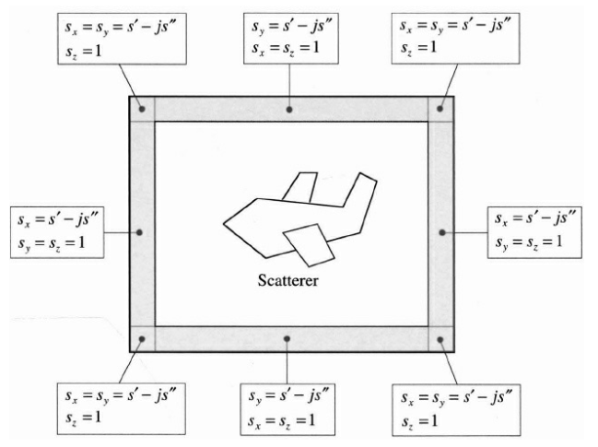
采用《坐标拉伸和各向异性介质关系》中的式子计算即可

二维 极坐标系
x-y-z坐标系下
$$∇×E=iωμH$$
$$∇×H=-iωϵE$$
u-v-w坐标系下
$$\left\{\begin{aligned}u=u\left(x,y,z\right) \\ v=v\left(x,y,z\right) \\ w=w\left(x,y,z\right)\end{aligned}\right. {∇×E^{'}=iωμ^{'}H^{'} \atop ∇×H^{'}=-iωϵ^{'}E^{'}}$$
其中
$$\left\{\begin{aligned}E^{'}\left(u,v,w\right)={\left(A^{T}\right)}^{-1}E\left(x,y,z\right) \\ H^{'}\left(u,v,w\right)={\left(A^{T}\right)}^{-1}H\left(x,y,z\right)\end{aligned}\right. \left\{\begin{aligned}ϵ^{'}\left(u,v,w\right)=\frac{Aϵ\left(x,y,z\right)A^{T}}{\det\left(A\right)} \\ μ^{'}\left(u,v,w\right)=\frac{Aμ\left(x,y,z\right)A^{T}}{\det\left(A\right)}\end{aligned}\right.$$
$$A=\left[\begin{matrix}\frac{∂u}{∂x} & \frac{∂u}{∂y} & \frac{∂u}{∂z} \\ \frac{∂v}{∂x} & \frac{∂v}{∂y} & \frac{∂v}{∂z} \\ \frac{∂w}{∂x} & \frac{∂w}{∂y} & \frac{∂w}{∂z}\end{matrix}\right] A^{-1}=\left[\begin{matrix}\frac{∂x}{∂u} & \frac{∂y}{∂u} & \frac{∂z}{∂u} \\ \frac{∂x}{∂v} & \frac{∂y}{∂v} & \frac{∂z}{∂v} \\ \frac{∂x}{∂w} & \frac{∂y}{∂w} & \frac{∂z}{∂w}\end{matrix}\right]$$

$${\overline{Λ}}_{(ρ,φ,z)}=\hat{ρ}\hat{ρ}\left(\frac{\tilde{ρ}}{ρ}\right)\left(\frac{s_{z}}{s_{ρ}}\right)+\hat{φ}\hat{φ}\left(\frac{ρ}{\tilde{ρ}}\right)\left(s_{z}s_{ρ}\right)+\hat{z}\hat{z}\left(\frac{\tilde{ρ}}{ρ}\right)\left(\frac{s_{ρ}}{s_{z}}\right)$$
$$=\left[\begin{matrix}\left(\frac{\tilde{ρ}}{ρ}\right)\left(\frac{1}{s_{ρ}}\right) & 0 & 0 \\ 0 & \left(\frac{ρ}{\tilde{ρ}}\right)\left(s_{ρ}\right) & 0 \\ 0 & 0 & \left(\frac{\tilde{ρ}}{ρ}\right)\left(s_{ρ}\right)\end{matrix}\right]$$
$\tilde{ρ}=ρ_{0}+\int_{ρ_{0}}^{ρ}{s_{ρ}\left(ρ^{'}\right)dρ^{'}} s_{ρ}=1-j\frac{{\left(\frac{ρ-ρ_{0}}{d}\right)}^{m}σ_{ρ,max}}{ωϵ} σ_{ρ,max}=-\frac{\left(m+1\right)\ln\left[R\left(0\right)\right]}{2ηd} d=ρ_{1}-ρ_{0}$
$$\tilde{ρ}=ρ_{0}+\int_{ρ_{0}}^{ρ}{\left(1-j\frac{{\left(\frac{ρ-ρ_{0}}{d}\right)}^{m}σ_{ρ,max}}{ωϵ}\right)dρ^{'}}=ρ_{0}+{\left(ρ^{'}-j\frac{dσ_{ρ.max}}{\left(m+1\right)ωϵ}{\left(\frac{ρ^{'}-ρ_{0}}{d}\right)}^{m+1}\right)}_{ρ_{0}}^{ρ}$$
$$=ρ_{0}+ρ-j\frac{dσ_{ρ.max}}{\left(m+1\right)ωϵ}{\left(\frac{ρ-ρ_{0}}{d}\right)}^{m+1}-ρ_{0}=ρ-j\frac{dσ_{ρ.max}}{\left(m+1\right)ωϵ}{\left(\frac{ρ-ρ_{0}}{d}\right)}^{m+1}$$
$$\frac{\tilde{ρ}}{ρ}=1-j\frac{dσ_{ρ.max}}{ρ\left(m+1\right)ωϵ}{\left(\frac{ρ-ρ_{0}}{d}\right)}^{m+1}$$
取$m=1$
$$\frac{\tilde{ρ}}{ρ}=1-j\frac{dσ_{ρ.max}}{2ρωϵ}{\left(\frac{ρ-ρ_{0}}{d}\right)}^{2} s_{ρ}=1-j\frac{{\left(\frac{ρ-ρ_{0}}{d}\right)}^{2}σ_{ρ,max}}{ωϵ}$$
$$\left[\begin{matrix}\left(\frac{\tilde{ρ}}{ρ}\right)\left(\frac{1}{s_{ρ}}\right) & 0 & 0 \\ 0 & \left(\frac{ρ}{\tilde{ρ}}\right)\left(s_{ρ}\right) & 0 \\ 0 & 0 & \left(\frac{\tilde{ρ}}{ρ}\right)\left(s_{ρ}\right)\end{matrix}\right]=\left[\begin{matrix}a & 0 & 0 \\ 0 & b & 0 \\ 0 & 0 & c\end{matrix}\right]$$
由$\left(ρ,φ,z\right)→\left(x,y,z\right), x=ρ\cos{φ},y=ρ\sin{φ}, z=z$
$$J=\left[\begin{matrix}\frac{∂x}{∂ρ} & \frac{∂x}{∂φ} & \frac{∂x}{∂z} \\ \frac{∂y}{∂ρ} & \frac{∂y}{∂φ} & \frac{∂y}{∂z} \\ \frac{∂z}{∂ρ} & \frac{∂z}{∂φ} & \frac{∂z}{∂z}\end{matrix}\right]=\left[\begin{matrix}\cos{φ} & -ρ\sin{φ} & 0 \\ \sin{φ} & ρ\cos{φ} & 0 \\ 0 & 0 & 1\end{matrix}\right] \det{J}=ρ$$
$$\tilde{ϵ_{r}}\left(x,y,z\right)=\frac{J\overline{Λ}ϵ_{r}J^{T}}{det⁡(J)} {\tilde{μ}}_{r}\left(x,y,z\right)=\frac{J\overline{Λ}μ_{r}J^{T}}{det⁡(J)}$$
能得到PML区域的各向异性介质参数：
$$\tilde{ϵ_{r}}\left(x,y,z\right)=ϵ\left[\begin{matrix}\frac{ax^{2}+by^{2}}{ρ^{2}} & \frac{(a-b)xy}{ρ^{2}} & 0 \\ \frac{(a-b)xy}{ρ^{2}} & \frac{bx^{2}+ay^{2}}{ρ^{2}} & 0 \\ 0 & 0 & c\end{matrix}\right]$$
$a=\left(\frac{\tilde{ρ}}{ρ}\right)\left(\frac{1}{s_{ρ}}\right),b=\left(\frac{ρ}{\tilde{ρ}}\right)\left(s_{ρ}\right),c=\left(\frac{\tilde{ρ}}{ρ}\right)\left(s_{ρ}\right)$
$\frac{\tilde{ρ}}{ρ}=1-j\frac{dσ_{ρ.max}}{2ρωϵ}{\left(\frac{ρ-ρ_{0}}{d}\right)}^{2} s_{ρ}=1-j\frac{{\left(\frac{ρ-ρ_{0}}{d}\right)}^{2}σ_{ρ,max}}{ωϵ} σ_{ρ,max}=-\frac{\ln\left[R\left(0\right)\right]}{ηd} η=\sqrt{\frac{μ}{ϵ}} ω=\frac{k}{\sqrt{μϵ}}$
$$\frac{σ_{ρ,max}}{ωϵ}=-\frac{\ln\left[R\left(0\right)\right]}{d}\sqrt{\frac{ϵ}{μ}}\frac{\sqrt{μϵ}}{kϵ}=-\frac{\ln\left[R\left(0\right)\right]}{k_{0}d\sqrt{μ_{r}ϵ_{r}}}$$

三维 笛卡尔坐标系
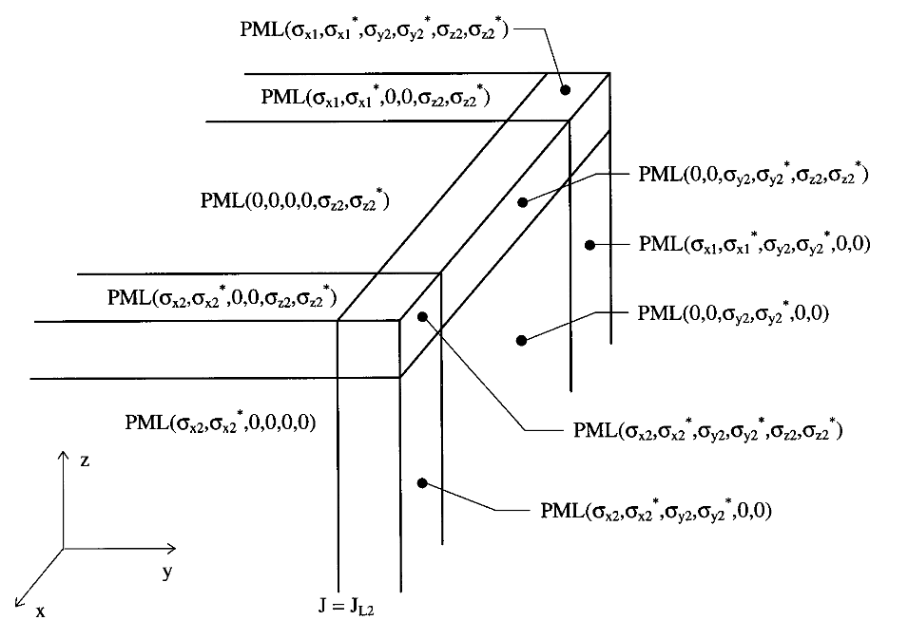
采用《坐标拉伸和各向异性介质关系》中的式子计算即可

三维 柱坐标
$$\overline{Λ}=\hat{ρ}\hat{ρ}\left(\frac{\tilde{ρ}}{ρ}\right)\left(\frac{s_{z}}{s_{ρ}}\right)+\hat{φ}\hat{φ}\left(\frac{ρ}{\tilde{ρ}}\right)\left(s_{z}s_{ρ}\right)+\hat{z}\hat{z}\left(\frac{\tilde{ρ}}{ρ}\right)\left(\frac{s_{ρ}}{s_{z}}\right)$$
$\tilde{ρ}=ρ_{0}+\int_{ρ_{0}}^{ρ}{s_{ρ}\left(ρ^{'}\right)dρ^{'}}$

三维 球坐标系
$$\overline{Λ}=\hat{r}\hat{r}{\left(\frac{\tilde{r}}{r}\right)}^{2}\left(\frac{1}{s_{r}}\right)+\left(\hat{θ}\hat{θ}+\hat{φ}\hat{φ}\right)s_{r}$$
$\tilde{r}=r_{0}+\int_{r_{0}}^{r}{s_{r}\left(r^{'}\right)dr^{'}}$

