A Perfectly Macthed Layer for the Absorption of Electromagnetic Waves 1993 Jean-Pierre Berenger
最早的文章
PML如果材料损耗突然增加，会导致反射（参考文献4-6）。因此需要多层网格，让损耗缓慢增加。在靠近分界面处损耗接近0。
$$σ\left(ρ\right)=σ_{m}{\left(\frac{ρ}{δ}\right)}^{n}$$
$δ$为PML总厚度，$ρ$为距离PML和普通材质交界面的距离，$σ_{m}和n$为常数
$$R\left(θ\right)=e^{-\left(\frac{2}{n+1}\right)\left(\frac{σ_{m}δ}{ϵ_{0}c}\right)\cos{θ} }$$
由上式子计算$σ_{m}$。其中c为光速
PML取值为$(m,n,R(θ))$ m为层数，n为上述公式变量，$R(θ)$用于计算$σ_{m}$

A FINITE-ELEMENT-METHOD FREQUANCY-DOMAIN APPLICATION OF THE PERFECTLY MATCHED LAYER CONCEPT 1995
坐标拉伸理解
$$\left(1-j\frac{σ}{ωϵ}\right) 1-j\frac{σ^{*}}{ωμ}$$
没有给出$σ$取值

A PERFECTLY MATCHED ANISOTROPIC ABSORBER FOR USE AS AN ABSORBING BOUNDARY CONDITION 1995
各向异性介质理解
$$\tilde{ϵ}=Λϵ \tilde{μ}=Λμ$$
$$Λ=\left[\begin{matrix}a & 0 & 0 \\ 0 & b & 0 \\ 0 & 0 & c\end{matrix}\right]$$
$a=b=\frac{1}{c}$

A Two-Dimensional Finite Element Formulation of the Perfectly Matched Layer 1996
$$σ\left(x\right)=\frac{\left(m+1\right)ϵc}{2d}\ln\left(\frac{1}{R}\right){\left(\frac{x-x_{0}}{d}\right)}^{m}$$
$$σ^{*}\left(x\right)=\frac{\left(m+1\right)μc}{2d}\ln\left(\frac{1}{R}\right){\left(\frac{x-x_{0}}{d}\right)}^{m}$$
c为光速，$R\left(θ\right)=R{\left(0\right)}^{COS\left(θ\right)}$。x方向的PML材料为（结构为x水平方向有PML）：
$${\tilde{ϵ}}_{r}^{x}=ϵ_{r}\left[\begin{matrix}\frac{1}{1-j\frac{σ}{ωϵ_{r}ϵ_{0}}} & 0 & 0 \\ 0 & 1-j\frac{σ}{ωϵ_{r}ϵ_{0}} & 0 \\ 0 & 0 & 1-j\frac{σ}{ωϵ_{r}ϵ_{0}}\end{matrix}\right] {\tilde{μ}}_{r}^{x}=μ_{r}\left[\begin{matrix}\frac{1}{1-j\frac{σ^{*}}{ωμ_{r}μ_{0}}} & 0 & 0 \\ 0 & 1-j\frac{σ^{*}}{ωμ_{r}μ_{0}} & 0 \\ 0 & 0 & 1-j\frac{σ^{*}}{ωμ_{r}μ_{0}}\end{matrix}\right]$$

A Comparison of Anisotropic PML to Berenger’s PML and Its Application to the Finite-element Method for EM Scattering 1997
坐标复拉伸和各向异性介质之间的关系

Systematic Derivation of Anisotropic PML Absorbing Media in Cylindrical and Spherical Coordinates 1997
笛卡尔坐标系下：
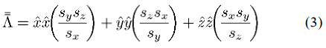
柱坐标系下：
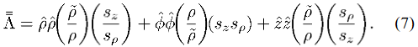
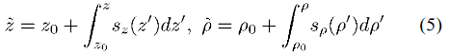
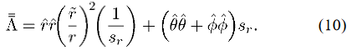
$\tilde{r}=r_{0}+\int_{r_{0}}^{r}{s_{r}\left(r^{'}\right)dr^{'}}$

Investigation of Nonplanar Perfectly Matched Absorbers for Finite-Element Mesh Truncation 1997
扩展至柱坐标、球坐标
柱坐标系下：
$${\left[Λ\right]}_{(ρ,ϕ,z)}=\left[\begin{matrix}a^{-1} & 0 & 0 \\ 0 & a & 0 \\ 0 & 0 & a\end{matrix}\right]$$
$a=1-j\frac{σ}{ωϵ_{0}}$，$[Λ]$的基为$\{a_{ρ},a_{ϕ},a_{z}\}$。
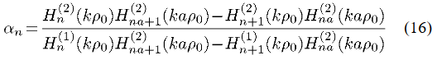
反射系数。对任意$k,n$反射系数都不为0，因此柱坐标下不存在理想的无反射PML
球坐标系下：
$${\left[Λ\right]}_{(r,θ,ϕ)}=\left[\begin{matrix}a^{-1} & 0 & 0 \\ 0 & a & 0 \\ 0 & 0 & a\end{matrix}\right]$$
$a=1-jσ$。需要先通过几个公式计算出反射系数$α_{m}=0$时的$a_{max}$
PML如果材料损耗突然增加，会导致反射。因此需要多层网格，让损耗缓慢增加。在靠近分界面处损耗接近0

On the development of a higher-order PML 2005
complex-frequency shifted PML (CFS-PML)
$$s_{i}=κ_{i}+\frac{σ_{i}}{α_{i}+jωϵ}$$
$$R\left(θ\right)=e^{-2σ_{i}ηd\cos{θ}(\frac{ω^{2}ϵ^{2}}{α^{2}}+ω^{2}ϵ^{2})}$$
二阶
$$s_{i}=(κ_{1}+\frac{σ_{1}}{α_{1}+jωϵ})(κ_{2}+\frac{σ_{2}}{α_{2}+jωϵ})$$
特殊形式$s_{i}=(1+\frac{σ_{1}}{jωϵ})(κ_{2}+\frac{σ_{2}}{α_{2}+jωϵ})$
一般PML
$$s_{x}=κ_{1}+\frac{σ_{1}}{jωϵ}$$
$$R\left(θ\right)=e^{-2σ_{i}ηd\cos{θ}}$$

PERFORMANCE OF REGULAR PML, CFS-PML, AND SECOND-ORDER PML FOR WAVEGUIDE PROBLEMS 2006
二阶PML
$$s_{x}=(κ_{1}+\frac{σ_{1}}{α_{1}+jωϵ})(κ_{2}+\frac{σ_{2}}{α_{2}+jωϵ})$$
CFS-PML
$$s_{x}=κ_{1}+\frac{σ_{1}}{α_{1}+jωϵ}$$
一般PML
$$s_{x}=κ_{1}+\frac{σ_{1}}{jωϵ}$$
取值方式：
$κ_{1}=κ_{2}=1$ $α=σ=mξ^{n}$，其中$m,n$为任意常数，$ξ$在PML和空气交界面处为0，在PML顶端为1

Anisotropic-Medium PML for Vector FETD With Modified Basis Function 2006
各向异性介质
$$Λ=\left[\begin{matrix}\frac{s_{y}s_{z}}{s_{x}} & 0 & 0 \\ 0 & \frac{s_{x}s_{z}}{s_{y}} & 0 \\ 0 & 0 & \frac{s_{x}s_{y}}{s_{z}}\end{matrix}\right]$$
$s_{j}=α_{j}+\frac{σ_{j}}{jω} j=x/y/z$，简单处理，$α_{j}=1$
$$σ=σ_{max}{\left(\frac{ρ}{d}\right)}^{n} σ_{max}=-\frac{\left(n+1\right)\ln\left|Γ\right|}{2ηd}$$
其中$ρ$为网格中心，n为阶数，$η$为自由空间阻抗，d为PML区域厚度，$\left|Γ\right|$为正入射时反射

Recent Advances in Perfectly Matched Layers in Finite Element Applications 2008
conformal PML 共形PML，即PML层和求解器件形状类似，可以不是方形或者球形
坐标变换

Comparison of high-order absorbing boundary conditions and perfectly matched layers in the frequency domain 2010
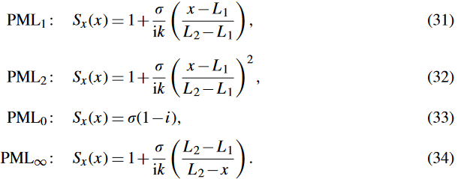
PML区域为从$x=L_{1}$到$x=L_{2}$

Full-Vectorial Finite Element Beam Propagation Method with Perfectly Matched Layers for Anisotropic Optical Waveguides
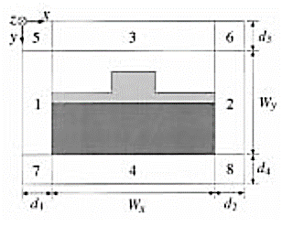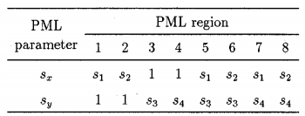
计算区域的材料参数$ϵ μ$
$PML$区域材料参数$\tilde{ϵ}=Λϵ \tilde{μ}=Λμ$
$$Λ=\left[\begin{matrix}\frac{s_{y}s_{z}}{s_{x}} & 0 & 0 \\ 0 & \frac{s_{z}s_{x}}{s_{y}} & 0 \\ 0 & 0 & \frac{s_{x}s_{y}}{s_{z}}\end{matrix}\right]$$
$$s_{j}=1-jα_{j} α_{j}=α_{j,max}{\left(\frac{ρ}{d_{j}}\right)}^{2} s_{z}=1$$

REFLECTIONLESS SPONGE LAYERS AS ABSORBING BOUNDARY CONDITIONS FOR THE NUMERICAL SOLUTION OF MAXWELL EQUATIONS IN RECTANGULAR, CYLINDRICAL, AND SPHERICAL COORDINATES
三维椭圆麦克斯韦方程：
$$-iωϵ\left(x^{'}\right)E^{'}=∇^{'}×H^{'} ∇^{'}⋅\left(ϵ\left(x^{'}\right)E^{'}\right)=0$$
$$-iωμ\left(x^{'}\right)H^{'}=∇^{'}×E^{'} ∇^{'}⋅\left(μ\left(x^{'}\right)H^{'}\right)=0$$
两个区域，$Ω_{c}$为内部区域，$Ω_{m}$为外部区域。相似变换：
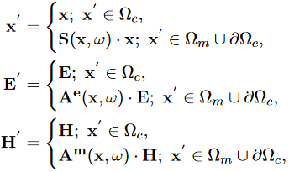
下标表示坐标空间。有$(x,ω)$
定义坐标拉伸$u^{'}=γ_{u}(u,ω)u$，有$u≥u_{0}$
$$γ_{u}\left(u,ω\right)=\frac{u_{0}+\int_{u_{0}}^{u}{α_{u}(s,ω)ds}}{u}$$
有$\frac{∂}{∂u^{'}}=ζ_{u}\frac{∂}{∂u}$，$ζ_{u}=\frac{1}{α_{u}\left(u,ω\right)}$（$ξ_{u}$和$ζ_{u}$不同）
与$α_{u}\left(s,ω\right)$的选择无关，论文的选择为：
$$α_{u}\left(s,ω\right)=ξ_{u}\left(1+\frac{iσ_{u}\left(s\right)}{ω}\right), xi_{u}≥1,$$
其中$σ_{u}\left(s\right)=σ_{u}^{max}{\left(\frac{s-s_{0}}{d_{u}}\right)}^{n}, n≥0且为整数, ξ_{u}$为实数，$σ_{u}^{max}$为正实数，$d_{u}$为$u$方向上长度

柱坐标系$\left(ρ,ϕ,z\right)$。在柱坐标系$Ω_{m}=R^{3}\backslash Ω_{c}$中$Maxwell^{'}s equations$：
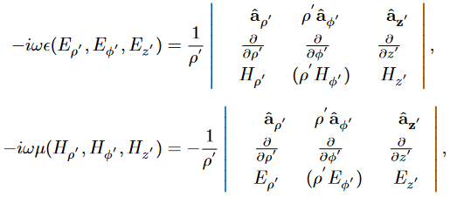
$Ω_{c}$区域为$0≤ρ^{'}<ρ_{0}, 0≤ϕ^{'}<2π, \left|z^{'}\right|<z_{0}$。$Ω_{m}$拆分为$Ω_{ρ}、Ω_{z}、Ω_{zρ}$几个区域。$Ω_{ρ}$区域$ρ^{'}≥ρ_{0}, 0≤ϕ^{'}<2π, \left|z^{'}\right|≤z_{0}$
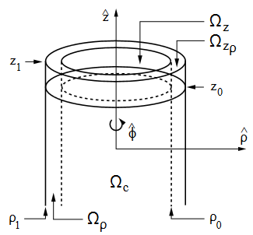
$u^{'}=γ_{u}(u,ω)u$坐标变换后有：
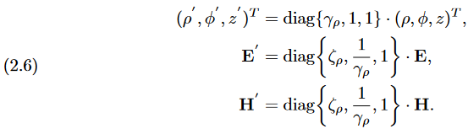
带入到柱坐标系下$Maxwell^{'}s equations$有：
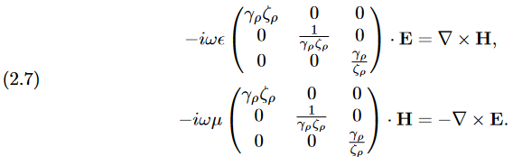
$$T=\left[\begin{matrix}γ_{ρ}ζ_{ρ} & 0 & 0 \\ 0 & \frac{1}{γ_{ρ}ζ_{ρ}} & 0 \\ 0 & 0 & \frac{γ_{ρ}}{ζ_{ρ}}\end{matrix}\right]$$
$γ_{ρ}\left(ρ,ω\right)=\frac{ρ_{0}+\int_{ρ_{0}}^{ρ}{α_{ρ}(s,ω)ds}}{ρ}, α_{ρ}\left(s,ω\right)=ξ_{u}\left(1+\frac{iσ_{ρ}\left(s\right)}{ω}\right), σ_{ρ}\left(s\right)=σ_{ρ}^{max}{\left(\frac{ρ-ρ_{0}}{d_{ρ}}\right)}^{n},ζ_{ρ}=\frac{1}{α_{ρ}(ρ,ω)}$
$R^{Ω_{ρ}}=e^{-2η\frac{ξ_{ρ}}{ω}\int_{ρ_{0}}^{ρ_{1}}{σ_{ρ}\left(s\right)ds}}, η=ω\sqrt{ϵμ}\cos{θ}, θ为入射方向和\overset{⃑}{ρ}方向的夹角. R^{Ω_{ρ}}$和笛卡尔坐标系中的$R$其实相同，看起来不一致是因为$η, σ_{ρ}$等定义不一样。
在$Ω_{zρ}$区域
$$T=\left[\begin{matrix}\frac{γ_{ρ}ζ_{ρ}}{ζ_{z}} & 0 & 0 \\ 0 & \frac{1}{γ_{ρ}ζ_{ρ}ζ_{z}} & 0 \\ 0 & 0 & \frac{γ_{ρ}ζ_{z}}{ζ_{ρ}}\end{matrix}\right]$$
$z^{'}=γ_{z}\left(z,ω\right)z$
在$Ω_{z}$区域
$$T=\left[\begin{matrix}\frac{1}{ζ_{z}} & 0 & 0 \\ 0 & \frac{1}{ζ_{z}} & 0 \\ 0 & 0 & ζ_{z}\end{matrix}\right]$$

